USER MANUAL

The file viewer is divided into three panes titled: Tools, Home Directory, and Server Directory.

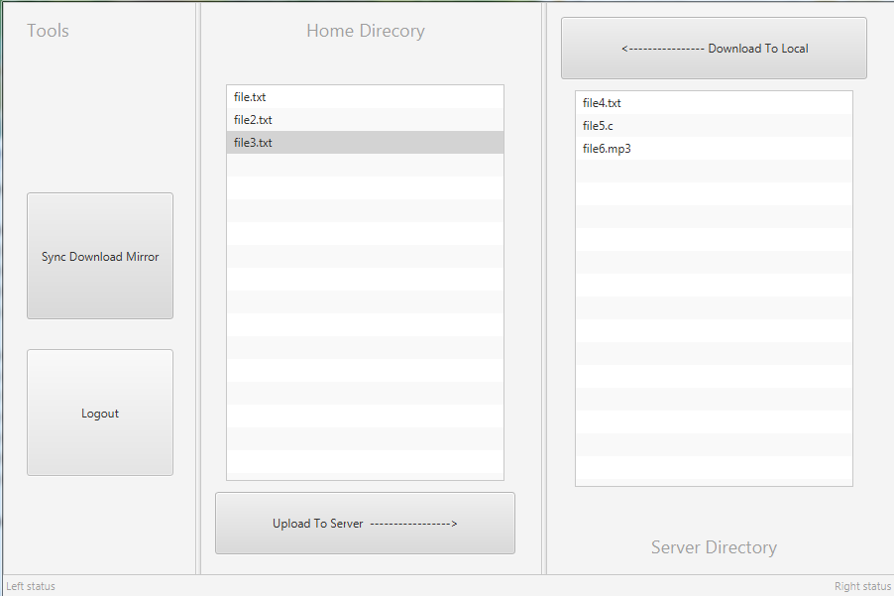

**Tools:**

* Users can Logout by clicking on the “Logout” button which would take the user back to the login screen.
* The “Sync Download Mirror” button copies everything in the server to a local folder.

**Server Directory:**

* In the server Directory pane all files uploaded by the client can be viewed, the uploaded file can be renamed or deleted by right clicking on the file in the server pane itself.
* A user also apart from being able to see the files on the server, would also be able to select and download this file from the server by clicking on the “Download To Local” button, even after changes have been made to the file(example change of file name) .

**Home Directory:**

* It looks for the folder in the root directory (in this case the desktop) and if it does not find the folder it would create it.
* The files stored in the client folder can be viewed by the client.
* To send a file to the server the user must first select one of the files listed by clicking on it, the selected file is highlighted in blue, afterwards the user must then click on the “Upload To Server” button when this is done the file which is displayed in the Home Directory would now also be displayed in the server Directory.